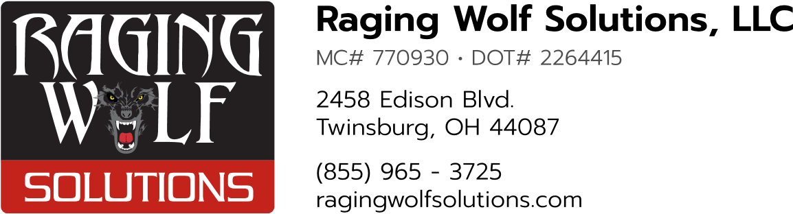

STANDARD OPERATING PROCEDURE (SOP)

# CreditSafe Credit Checks

1. **Purpose** - The purpose of this SOP is to outline the steps to be followed by the Operations team when performing credit checks using CreditSafe for prospective customers.
2. **When to Perform a Credit Check** - A credit check must be performed in these scenarios…
   * + For any prospective customer that we have not done business with before. The check must be done before providing a quote or rate to the customer.
     + For any existing customers that we have not done business within the past 12 calendar months. The check can be performed at any time during the process of quoting or booking their load.
3. **Performing a Credit Check**
   * Search for the prospective customer's company using CreditSafe.
   * Generate a report for the company.
   * Review the report, paying close attention to the CreditSafe Score, Risk Score, DBT, Company Details, Payment Trend, Payment Experiences, Industry Breakdown, and DBT Peer Analysis.
   * Check the related companies, branches, subsidiaries, etc. listed under the 'Group' tab. e. If a record with confusing, inaccurate, or out-ofdate information is found, send the company 'Safe Number' to Bonnie at CreditSafe. Safe Numbers can also be sent to Bonnie at CreditSafe when two or more records need to be merged.
   * If a company cannot be found in CreditSafe, perform a 'Director' search for executives who work for/at that company. Ask the

Raging Wolf Solutions, LLC. Proprietary Document

prospective customer for any potential DBA names or if 'Branch' or 'HQ' takes care of billing.

* + Add the company to CreditSafe monitoring or portfolios for existing customers to receive updates and notifications of any negative activity.
  + Provide a PDF or exported version of the report to the Accounting team.

1. **Evaluating a Credit Report** – Evaluate each of the following risk factors. Companies with multiple concerning risk factors must receive a management review and approval:

* **CreditSafe Score:** This is a number from 0 to 100 scale which directly correlates to a relational level of risk. A higher score indicates a lower the risk of default or bankruptcy while a lower score identifies higher risk of default or bankruptcy. The CreditSafe Score is created by their in-house analytics division using key data variables proven to have an impact when a business fails. These variables include financials, trade payments, demographic, industry, legal filings, group structure, size of business and more.
* **Risk Score:** This is an alphanumeric rating from A+ (lowest risk) to D (highest risk) that represents the probability of a company becoming insolvent within the next 12 months. The Risk Score is based on various factors such as financial performance, payment behavior, industry sector, legal events and more. If a company’s risk score falls below a B, consider the other risk factors.
* **DBT:** This stands for Days Beyond Terms and it measures how long it takes for a company to pay its invoices past their due date. DBT can indicate how well a company manages its cash flow and whether it has sufficient liquidity to meet its obligations. A high DBT can signal financial distress or poor payment practices.
* **Company Details:** This section provides basic information about the company such as name, address, phone number, website, registration number, incorporation date and status. It also shows the company’s main activity code and description based on SIC (Standard Industrial Classification) codes. Company details can help you verify the identity and legitimacy of the company you are dealing with.
* **Payment Trend:** This shows how the company’s payment behavior has changed over time compared to its industry average. It displays a graph of monthly DBT values for up to 24 months along with colorcoded indicators for above average (red), average (yellow) or below average (green) performance. Payment trend can help you assess whether the company’s payment habits are improving or deteriorating over time.
* **Payment Experiences:** This shows how many trade creditors have reported their payment experiences with the company in terms of number of invoices paid on time or late within different time periods. It also shows the total value and percentage of invoices paid on time or late within each period. Payment experiences can help you evaluate how reliable and consistent the company is in paying its suppliers.
* **Industry Breakdown:** This shows how the company’s payment behavior compares to other companies in its industry sector based on DBT values. It displays a pie chart showing the percentage distribution of companies within different DBT ranges along with color-coded indicators for low risk (green), medium risk (yellow) or high risk (red) categories. Industry breakdown can help you benchmark the company against its peers and identify any outliers or trends in its sector.
* **DBT Peer Analysis:** This shows how the company’s payment behavior compares to other companies of similar size and age based on DBT values. It displays a bar chart showing the average DBT for each quartile of companies within different turnover and age ranges along with color-coded indicators for low risk (green), medium risk (yellow) or high risk (red) categories. DBT peer analysis can help you understand how the company performs relative to its competitors and potential customers.

1. **Management Review** (as needed) – When a company report contains multiple concerning risk factors, management will make the final determination on credit worthiness. Scott Brownfield (Company President) is the primary contact for this decision, and Rich Metz (Operations) is the backup contact for this decision.

- **NOTE: management approval should be given *before* any shipments are booked with this company.**

1. **Disputes** - If a prospective customer disputes our rejection due to their CreditSafe report, Bonnie can handle the dispute with the customer and either work with us to change the decision or confirm our decision.
2. **Conclusion** - Performing credit checks using CreditSafe is an essential step in assessing the risk of doing business with prospective customers. Following this SOP will ensure that the Operations team performs thorough credit checks and reduces the risk of financial loss due to non-payment or default.

If you have further questions, you may refer to this [webinar](https://www.creditsafe.com/us/en/resources/webinars/how-to-read-a-creditsafe-credit-report.html) for more details, or speak to your manager.